A Project Report

On

**Art Shopee**

Developed At

**Harivandana College**

For the fulfillment of the requirements for the

**B.C.A. – 5th Semester [2021]**

**Developed By**

**SNEHAL KANZARIYA**

Submitted To



**DEPARTMENT OF COMPUTER SCIENCE**

**-: Under the Guidance of :-**

**Dr. Ashwin Rathod (Head of Department)**

**Prof. Dharmendra Ambani (Project In-charge)**

**ACKNOWLEGEMENT**

❖ We are very thankful to the project coordinator of Prof. Swati chavda, Prof. Bhavesh chavda and Prof. Harshad Fefar of Harivandana College, who has provided us a lot of support & guidance from the beginning to the end of the project development.

❖ A work of this nature would not have been possible without the encouragement and meticulous attention received from them. The faculties has also played a vital role in building up my project website, under their guidance and training it became much easier to develop a project.

❖ A work of this nature would not have been possible without encouragement and meticulous attention received from them. Prof. Harshad Fefar and Prof. Swati chavda their constant help, lots of suggestions, thoughtful tips & deep interest in this system, has enabled us to complete this work very easily & as much nicely as it would not be otherwise.

|  |  |  |  |  |  |  |  |
| --- | --- | --- | --- | --- | --- | --- | --- |
|  | **No** |  |  |  | **Subject Title** |  | **Page No.** |
| **1** | | **Introduction** Scope of project Purpose  Technologies and Literature Review | | | | **6** | |
| **2** | | **System Requirements and study**  User Characteristics  Hardware software requirement  Consraints  Detailed description of functional requirement | | | | **11** | |
| **3** | | **System Analysis**  Study of current system  Requirements of new system  Overview of proposed system | | | | **16** | |
| **4** | | **Project management**  Project planning and scheduling | | | | **21** | |
| **5** | | **User case**  Administrator function | | | | **26** | |
| **6** | | **Data dictionary**  Art-Shopee  Admin  Category  Product Registor | | | | **29** | |
| **7** | | **Data flow diagram**  Use case  DFD diagram  ER diagram  Sequence diagram | | | | **31** | |
| **8** | | **Screenshot** | | | | **43** | |

|  |  |  |
| --- | --- | --- |
| **9** | **Implementation planning and details**  Implementation  environment  Testing method | **60** |
| **10** | **Testing**  Testing plan Testing strategy | **62** |
| **11** | **Limitation and future enhancement**  Benefit  Limitation  Conclusion | **66** |

1. **Introduction**

➢ ‘Art Shopee’ is an Ecommerce website dedicated to finding and selling

The Arts for who has love and feel the arts reality or deepness of art.

➢ This is online buy or seal arts portal.

➢ This website for arts it is helpful for who find the Arts for them or other and who want to share or sell their art creativity.

➢ All types arts are available almost complement running.

➢Like Digital art, Painting, Drawing, Sculpture, Photography

Street art, etc.

➢ All types of arts are available on the site. Artist can sell their arts and people who want to buy arts. People buy arts for their office, hotel, for looking attractive their home, library wherever you want to use that arts.

➢ User see the gallery of arts freely you can participant in sale all types of users give their kind Reviews and Much More, You can review arts and asking to question to the art related. You get solution of your doubts.

❖ **SCOPE OF PROJECT:**   

➢ The efficient Art Shop enables to sell & buy the

Particular arts .Admin and Artist add the category and product(arts) dynamically.

➢ Fool proof security for collection of any product.

➢ The desired art is available in different prints also in different styles.

➢ Maintains data about the arts.

➢ Arrange the data of site in logical order for easy to maintenance.

 

❖ **PURPOSE:**

➢ The main purpose of our website is to make easy availability of all different kinds of Arts like as Painting, Sculpture, Literature, Architecture, Abstract art, Morden art, Pop art, etc. to the people our website provides.

➢ The best Art of the Many styles and prints are at the reasonable rates.

➢ As today’s modern and fast world you want to style with today’s

world and you can decorate your home, hotels, and offices.

➢ Our website is the easy to provide art and availability to art collector

and art seller to buy and sell arts .

❖ **Technologies and Literature Review:**

PHP is scripting language that lets you create dynamic Web pages. PHP is a server-side scripting language. The PHP language interpreter must be installed on the server-side in order to execute PHP commands. When a page containing PHP commands is requested from a PHP enabled server hands over the page to the PHP interpreter. The output (usually in the form of HTML) of the interpreter execution is sent back to the client that requested the page. Thus, a dynamic Web Page is created.

If you are familiar with the basic syntax you won’t have problems with the PHP syntax. PHP makes it possible to perform mathematical calculations, to handle regular expressions, to control the flow of a program execution, to send e-mails, to establish.

➢ **PHP:**

PHP is a web scripting language, this language is used for developed it project. Many file are create in Php file and use with. CSS and complete a design to home page and other page. PHP in a many class and session are create and use for some output. However, PHP is the best known for its database interfacing capabilities. With PHP you can establish a database connection to any of standard database servers. Update the content of a database, even manipulate a particular database schema. The results of queries are easily converted into a valid HTML that is sent back to the client. Currently PHP seems to be best technological solution for providing a WWW gateway to a database server. One of the reasons that PHP is so powerful is that is a goal-oriented language. It is made to accomplish things, quickly and easily.

➢ **MySQL:**

MySQL is an open source, SQL Relational Database Management System (RDBMS) that is free for many uses. One of the most powerful features of that PHP offers is its database connectivity. It has never been so easy to connect to a database management server, to update the content of a particular database, or to retrieve the data from a particular database, as it is the case by means of using simple PHP scripts. Another very useful PHP feature is that a standard PHP distribution comes with a number of standard function libraries which allow users to write scripts that connect to a wide range of currently popular database management systems. There is, for instance, a function library for manipulating MySQL databases, Oracle databases, Informix database

The script uses the MYSQLI_CONNECT() function in order to establish a connection to MySQL server. The MYSQLI_CONNECT() function takes three values as its arguments:

1. Hostname – the name of the host to which to establish the connection. In our case it is the localhost because both servers: the Web server and the MySQL server are running on the same machine.

2. Username – the name of a user that has privileges to manipulate the test database that we created.

3. Password – the valid password of the user.

➢ **PhpMyAdmin:**

PhpMyAdmin can manage a whole MySQL server (needs a super-user) as well as single database. To accomplish the latter you’ll need a properly set up MySQL user who can read/write only the desired database. It’s up to you to look up the appropriate part in the MySQL manual. Currently PhpMyAdmin can:

▪ create and drop databases

▪ create, copy, drop, rename and alter tables

▪ do table maintenance

▪ Delete, edit and add fields

▪ execute any SQL-statement, even batch-queries

▪ manage keys on fields

**2. System Requirements and Study**

**User characteristics:**

There are three types of users in this system:

➢ The highest level of user is the administrator *who* reserves all the rights of administrative work in the Art Shopee.

**Administrator:**

➢  Administrator will be given a unique ID and password to login.

➢  Admin can insert, update delete and read data.

➢  Admin allowed permission user.

➢  Admin managed feedback all users.

**Normal Users (Buyer):**

➢  All user visits our website.

➢  User can send the feedback to admin or artist.

➢  User can purchase any arts.

➢  User can view all arts details.

**Artist:**

➢  Artist has must Sign up before he sealing their arts. And after then he will

whenever he wants to sell their arts he will login and sell their arts

➢  Artist can insert, update delete their particular product and read all data.

➢  Artist managed their product feedback from all users. But I am working on this panel in future

**HARDWARE SOFTWARE REQUIREMENT**

❖ **SOFTWARE REQUIREMENTS**

Desktop OS: Windows 7/8/10

Xampp

Apache

MySQL server

Editor for code writing like VS code

Browser like: Chrome, Firefox

❖ **HARDWARE REQUIREMENTS**

**Client side**: -

Minimum o. s windows 7

Browser software

Internet services or local host server

**Server side**: -

Min 250GB hard-disk

1GB RAM

WebServer

OS

Pentium III or advanced processed

❖ **CONSTRAINTS**

➢ **User Interface:**

The user Interface is provided by the any kind of web browser like Internet Explorer, chrome, Mozilla Firefox etc.

➢ **Communication Interfaces:**

This is website so it requires HTTP protocol and Internet connection.

➢ **Software Interface:**

The application mainly interacts with the SQL SERVER database for storing data at the back end. Other than that it doesn’t deals with any software.

❖ **Detailed Description of Functional Requirement**

➢ **Purpose:**

‘Art Shopee’ project purpose is buy great collection of Arts and in future I am working on artist panel its purpose is artist also can sell their arts on my site.

➢ **Inputs:**

At the admin part the details of all user like admin user, normal user (buyer), or artist also in future. In present admin can add categories and product and also delete or update category and product.

➢ **Processing:**

The processing contains validations of user inputs and give response as user requirement.

➢ **Outputs:**

The arts and its detailed also viewed at user as well as the admin side.

**3. System Analysis**

❖ **Study of current system:**

➢ Current system to saw an art then easily buy any arts.

➢ Current system to category details to saw then read to category.

➢ Current system to check user whenever user try to buy any product that time he was must be login user.

➢ Current system to popular of buying arts easily.

❖ **Requirements of new system:**

➢ All the user’s in India needs the smart work & easy availability of any items but sometimes they can’t find good items specially I am talking about you can’t find best arts that time we are provides good arts to the user easily at best price.

➢ Upgraded Art of new system between old system. Our new system to product category wise saw. Our new system to provide an add new and upgraded product. our new system to provide very more Art to facility wise.

❖ **Overview of proposed system:** 

➢ New system is online system so customer can get all information at

anywhere at any place .

➢ The admin and users can get all the detail of arts its vary data purity &

Surety. Users have multiple choice for purchasing arts.

 **Hardware**

The project of Artshopee Website will be compatible on every Browser. Operating systems like Windows 7/8 and higher versions will support it.

❖ **Software**:

(1) Front end tools PHP

(2) Back end tool: MySQL server

❖ **Feasibility** **Study**:

Preliminary investigations examine project feasibility; the likelihood the system will be useful to the organization. Three tests of feasibility-all equally important – are studied: operational, technical and financial.

❖ **Operational** **Feasibility**:

Proposed projects are beneficial only if they can be turned into ecommerce systems that will meet the organization’s operating requirements. To know whether system will work when implemented, here are some points we will look when we market the project.

* Is there a sufficient support for the project from management? From users? Is there a reason for change?
* Are current methods of business acceptable to users? If not they might welcome the change.
* We will try to involve users as much as possible through training to reduce chances of resistances.
* Most importantly assessment is done to assure that the proposed system will not cause harm or poor results in any respect or area and will not slow performance of any individual or organization.

❖ **Does the System provide adequate throughput and response time?**

Yes. The response time of the system is satisfactory and not very time consuming.

❖ **Does the System provide the End-users with timely pertinent, accurate and usefully formatted information?**

Yes, the system will provide to the end users with accurate information about the system .The information will be in such a formatted manner that any non- technical person will also be able to use it in a proper way.

➢ **Technical Feasibility:-**

For end users they just require username and password printing facility to manage their arts shopping. And we are developing website using most recent Apache web server (xampp), which uses MySQL Developer as database. It is capable to store data and provide concurrent access to information and adequate responses accurately. Also we will try our system to make it as expandable as possible. We also provide reliability, ease of access, and data security because this is not a final project.

❖ **Do we currently process the necessary technology?**

Yes, we possess the necessary technology but according to that we also have the necessary configured peripherals. So, we are capable of using that technology in our system.

❖ **Economic Feasibility**

The cost required for the creation of our system will be less compared to the benefits provided by our system. Our system will provide both the types of benefits i.e. Tangible as well as Non-tangible.

This system is user friendly so anyone who have a basic knowledge of computer & Internet then he/she can use easily access. And it is also low cost because no need to attach extra hardware.

**4. PROJECT MANAGEMENT**

Project Management is an important part of project development. It deals with all the main areas of the project development like Feasibility, Requirement analysis, Project Schedule, Project Plan etc. We have used the Project Management approach to deal with all these areas. It is achieved by proper selection of Software Life Cycle Model.

❖ **PROJECT PLANNING AND SCHEDULING**

Project planning is perhaps one of the most important works in developing works in developing any project. Before the project can begin estimate regarding work to be done, what recourse’s will be required and how much time will elapse from start to the finish of a project. Planning helped us to prepare a framework that enabled to make us a reasonable estimate of all such things.

➢ **Project development Model**

• **Software Development Process: Waterfall Model**

In the waterfall model, a project progresses through an orderly sequence of steps from the initial software concept through system testing. The project holds a review at the end of each phase to determine whether it is ready to advance to the next phase - from requirements analysis to architectural design. If the review determines that the project isn't ready to move to the next phase, it stays in the current phase until it is ready.

The waterfall model is document driven, which means that the main work products that are carried from phase to phase are documents. In the pure waterfall model, the phases are also discontinuous - they do not overlap. The following shows how the pure waterfall lifecycle model progresses.

The pure waterfall model performs well for product cycles in which you have a stable product definition and when you're working with well-understood technical methodologies. In such cases, the waterfall model helps you to find errors in the early, low-cost stages of a project. It provides the requirement stability that developers crave. If you're building a well- defined maintenance release of an existing product or porting an existing product to a new plat. Form, a waterfall lifecycle might be the right choice for rapid development.

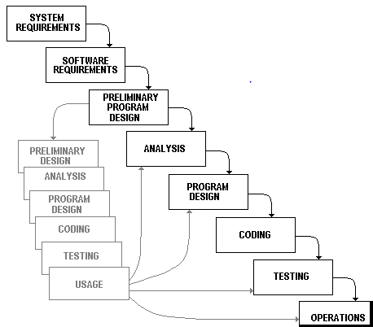

❖ **Phases**

Incremental development slices the system functionality into increments (portions). In each increment, a slice of functionality is delivered through cross-discipline work, from the requirements to the deployment. The unified process groups increments/iterations into phases:

❖ **Inception, elaboration, construction, and transition:**

Inception identifies project scope, requirements (functional and non-functional) and risks at a high level but in enough detail that work can be estimated.

Elaboration delivers a working architecture that mitigates the top risks and fulfills the non-functional requirements.

Construction incrementally fills-in the architecture with production-ready code produced from analysis, design, implementation, and testing of the functional requirements.

Transition delivers the system into the production operating environment.

❖ **PROJECT PLAN:**

➢ A plan is drawn up at the start of the project, should be used as the driver of the project. The project planning consists of:

➢  Selection of suitable software development process model which I have selected Interactive Water Fall Model.

➢ Risk Management Plan, which involves the risk identification and risk assessments.

❖ **MILESTONES AND DELIVERABLES:**

➢ **Milestones:**

Milestone is an end-point of the software process activity.

At each milestone there should be formal output, such as report, that can be represented to the management.

Milestone report need not be large document; they are the short report of achievements in software project activity.

Milestone represents the end of the distinct, logical stage in the project.

➢ **Deliverables**

Deliverable is a project report that is delivered to user.

Deliverables are delivered to the user at the end of the same major project phase such as specification, design, etc.

Deliverables are usually milestones.

Milestones may be internal project results that are used by the project manager to check progress but which are not delivered to the user.

**5. User Case**

1. **Use case: Profile:**

❖ **Diagram:**

User

➢ **Description:**

The user register his/her profile after the successfully login.

➢ **Initial Step-By-Step Description**

First user has to register in community.

The system displays the various links.

❖ **Administrator Function**

**➢ Manage Users:**

1. The administrator will be able Delete -Enable-Disable users.

2. The administrator will be able to Activate-Inactivate the users. If a user is inactive, the user shall not be able to log in to make new profile & post or see old ones.

3. The administrator will have full authority over all the users.

4. The administrator will be able to see the entire user saved Profile and Post.

➢ Manage Images:

1. The administrator shall be able to upload New Images for the users to use.

2.The administrator will be able to delete old images.

**6. Data Dictionary**

**Art Shopee**

**➢ Admin**

|  |  |  |  |  |
| --- | --- | --- | --- | --- |
| Table Name | | **admin_register** | | |
| Description | | This table is used to maintain and store the information related to Admin. | | |
| Primary Keys | | Id | | |
|  | | - | | |
| Key | Field Name | Type | Size | Constraints |
| * | Id | Integer | 20 | Not Null |
|  | username | Varchar | 50 | Not Null |
|  | email  password | Varchar  Varchar | 50  8 | Not Null  Not Null |

➢ **Category**

|  |  |  |  |  |
| --- | --- | --- | --- | --- |
| Table Name | | **Category** | | |
| Description | | This table is used to maintain and store the information related to Category. | | |
| Primary Keys | | Id | | |
| Foreign Keys | | - | | |
| Key | Field Name | Type | Size | Constraints |
| * | Id | Integer | 10 | Not Null |
|  | cat_name | Varchar | 200 | Not Null |
|  | cat_img | Varchar | 100 | Not Null |
|  | Time | bigint | 50 | Not Null |
|  |  |  |  |  |

➢ **Contact**

|  |  |  |  |  |
| --- | --- | --- | --- | --- |
| Table Name | | **Contact** | | |
| Description | | This table is used to maintain and store the information related to Contact. | | |
| Primary Keys | | c_id | | |
| Foreign Keys | | - | | |
| Key | Field Name | Type | Size | Constraints |
| * | c_id | Integer | 30 | Not Null |
|  | c_unm | Varchar | 50 | Not Null |
|  | c_email | Varchar | 50 | Not Null |
|  | c_mno | Integer | 10 | Not Null |
|  | c_msg | mediumtext | - | Not Null |
|  | c_time | Bigint | 30 | Not Null |
|  | c_status | Integer | 1 | Not Null |

➢ **Product**

|  |  |  |  |  |
| --- | --- | --- | --- | --- |
| Table Name | | **Product** | | |
| Description | | This table is used to maintain and store the information related to Product. | | |
| Primary Keys | | Id | | |
| Foreign Keys | | - | | |
| Key | Field Name | Type | Size | Constraints |
| * | Id | Integer | 5 | Not Null |
|  | p_name | Varchar | 100 | Not Null |
|  | p_desc | Varchar | 300 | Not Null |
|  | Price | Mediumint | 230 | Not Null |
|  | Sale_price | Mediumint | 230 | Not Null |
|  | Qty | int | 50 | Not Null |
|  | Stock_status | Varchar | 20 | Not Null |
|  | p_cat | Varchar | 200 | Not Null |
|  | P_img | Varchar | 200 | Not Null |
|  | Time | Bigint | 30 | Not Null |

**➢ Signup user**

|  |  |  |  |  |
| --- | --- | --- | --- | --- |
| Table Name | | Signup_user | | |
| Description | | This table is used to maintain and store the information related to Register(sign up). | | |
| Primary Keys | | Id | | |
| Foreign Keys | | - | | |
| Key | Field Name | Type | Size | Constraints |
| * | id | Integer | 20 | Not Null |
|  | email | Varchar | 30 | Not Null |
|  | username | Varchar | 50 | Not Null |
|  | password | Varchar | 8 | Not Null |

➢ **Sell art**

|  |  |  |  |  |
| --- | --- | --- | --- | --- |
| Table Name | | Sell_art | | |
| Description | | This table is used to maintain and store the information related to Sell art. | | |
| Primary Keys | | Sp_id | | |
| Foreign Keys | | - | | |
| Key | Field Name | Type | Size | Constraints |
| * | sp_id | Integer | 50 | Not Null |
|  | sp_name | Varchar | 100 | Not Null |
|  | sp_desc | Varchar | 300 | Not Null |
|  | price | Mediumint | 230 | Not Null |
|  | Sale_price | Mediumint | 230 | Not Null |
|  | sp_qty | int | 50 | Not Null |
|  | Stock_status | Varchar | 20 | Not Null |
|  | sp_cat | Varchar | 200 | Not Null |
|  | sp_img | Varchar | 200 | Not Null |
|  | time | Bigint | 50 | Not Null |

**7. Data Flow Diagram**

❖ **Data Flow Diagram from user side**

**Art Shopee**

Add category

Add Product

**Login**

cart

Products

Login

Register

Contact

Pages

Sellprojectt

Home

**Admin**

**Client**

❖ **Use Case Diagram**

Login

Register

User Admin

Database

**Client Side Use Case**

**Register**

**Login**

**Database**

**View Arts**

**Add to Cart**

Normal

User

**Payment(future)**

❖ **Admin side use case**

**Login**

**Add Category**

**Add Product**

**View Product**

**Database**

**View Category**

Admin

**DFD DIAGRAM (Data flow diagram)**

➢ **Client Side**

**Registration**

**Registration**

**Login**

**Database**

**Valid**

**Login**

**Add to Cart**

**Order Art**

**Logout**

**About Us**

➢ **Admin side**

**Edit / Delete**

**Home**

**Add category**

**View Category**

**Add Product**

**View Product**

**Log out**

* **Sequence diagram for User Registration:**

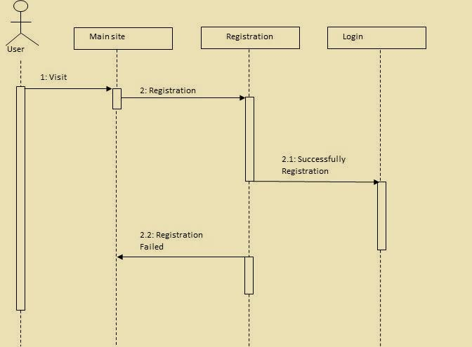

** **

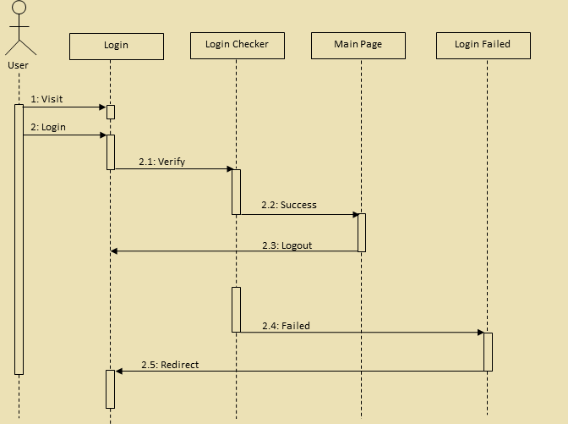

**8. Screenshot**

❖  **Client side Header**

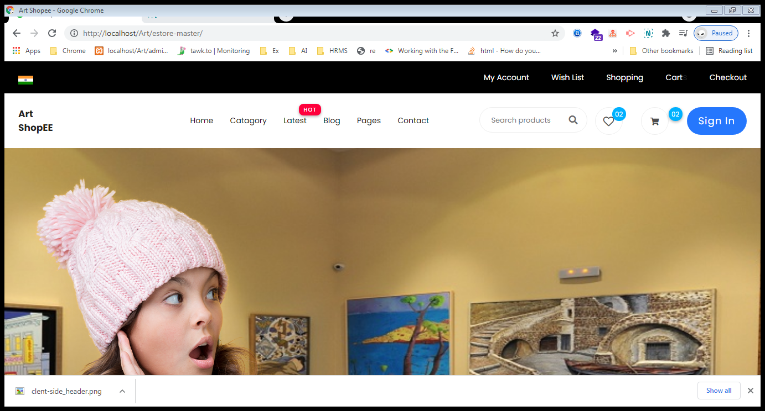

❖  **Client side Home Product**

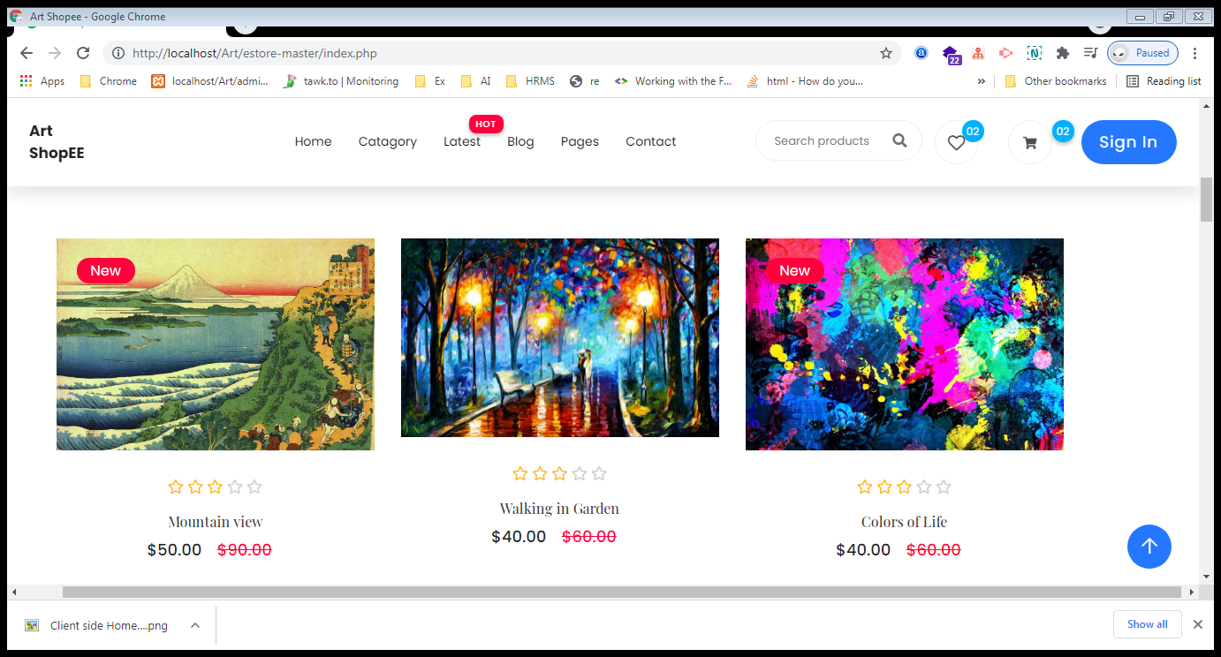

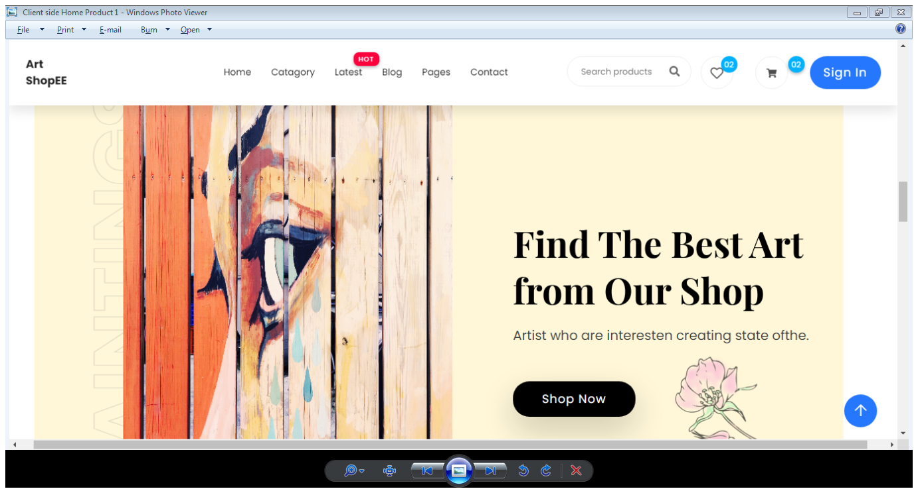

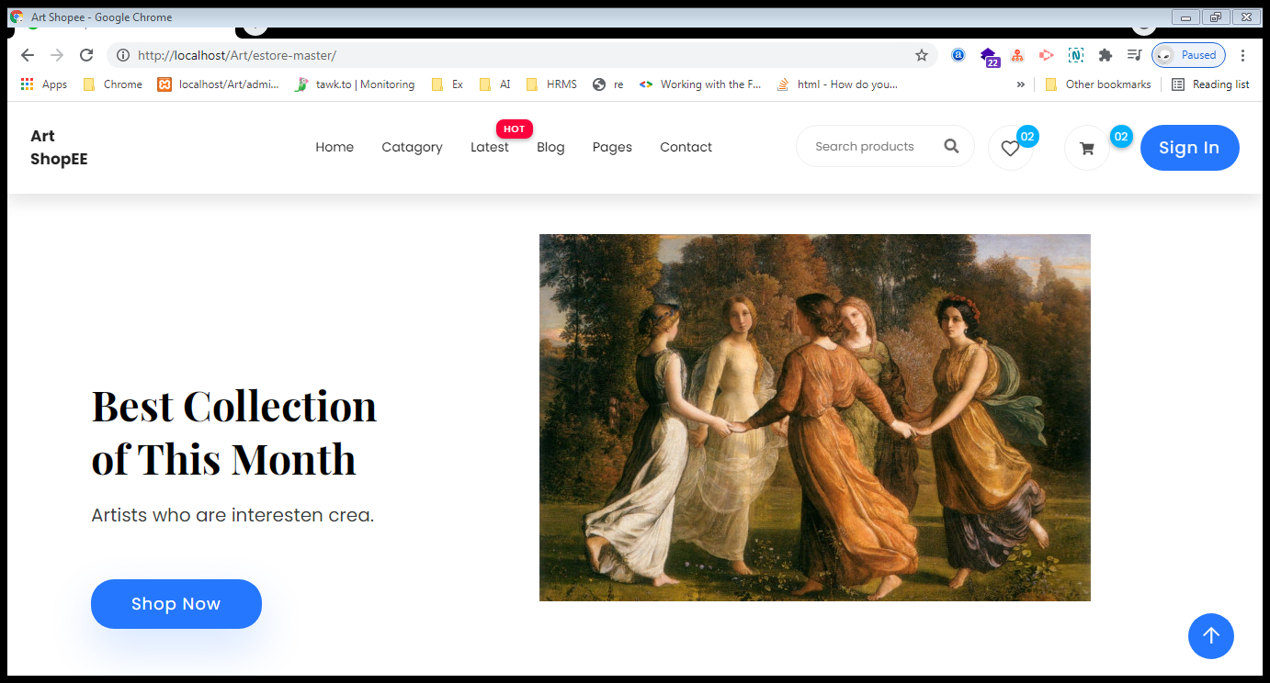

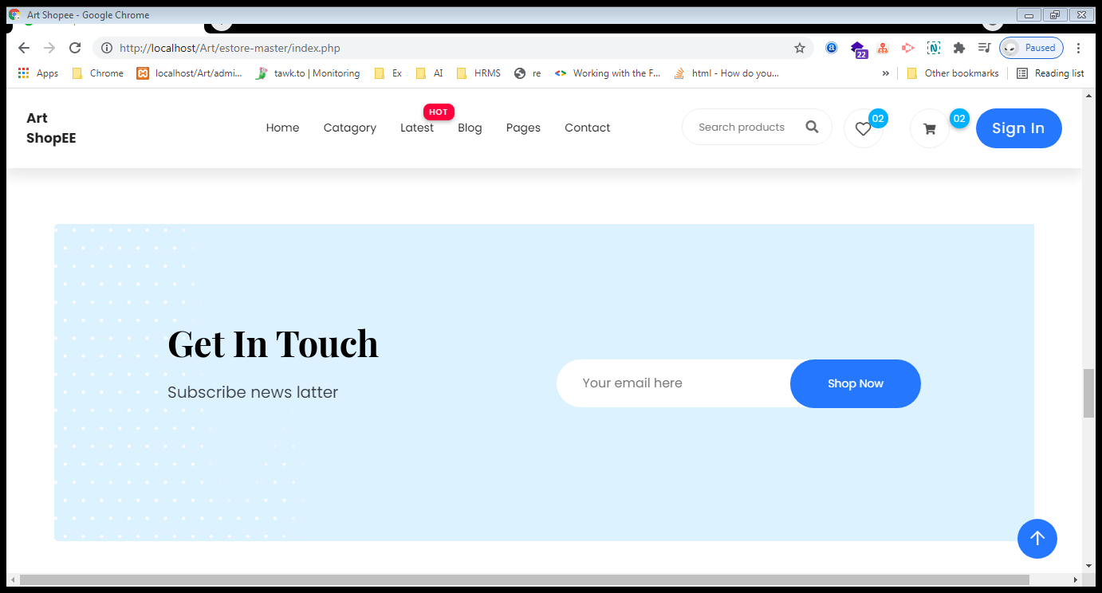

❖  **Client side Footer**

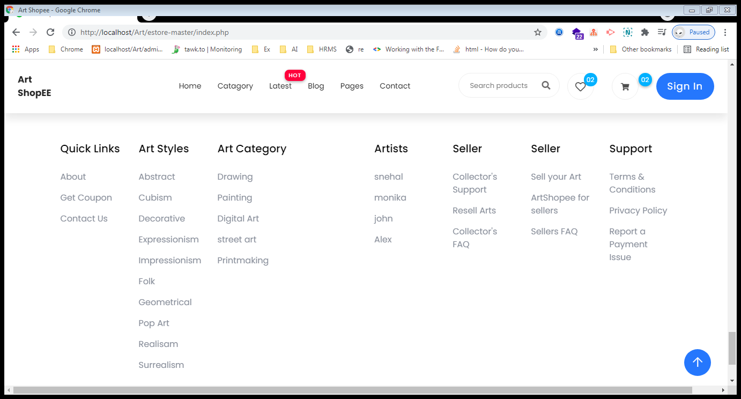

❖  **Client side product page**

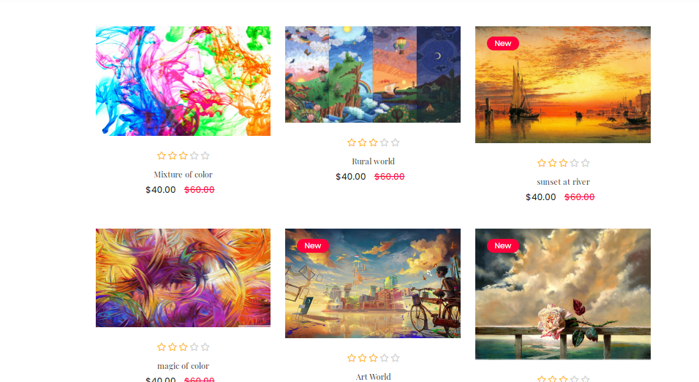

❖  **Client side project Cart Page**

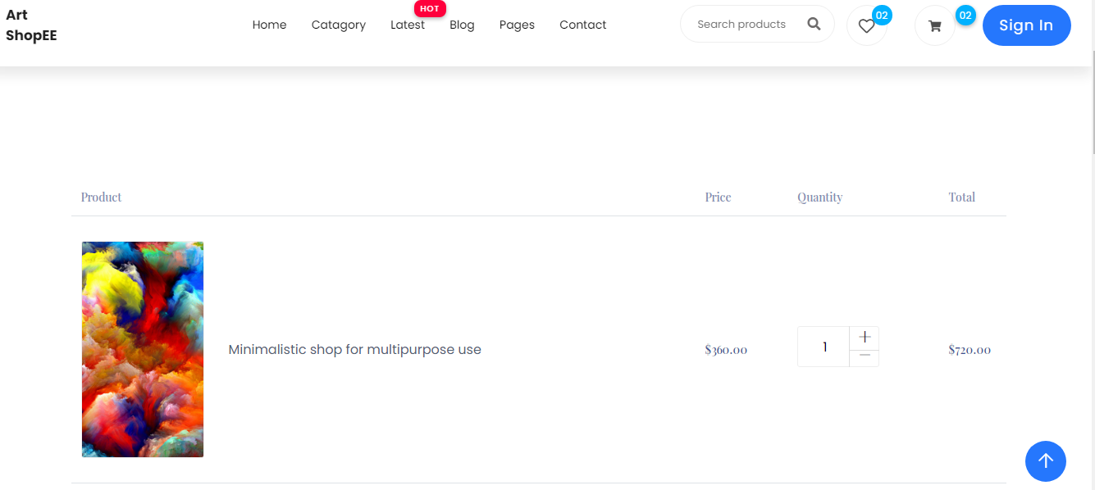

❖  **Client side User Register Page**

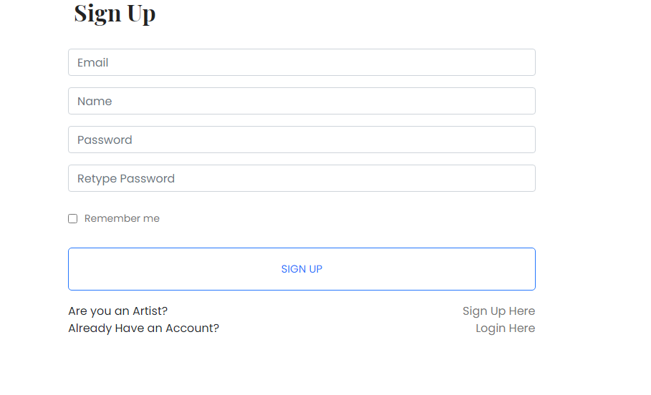

❖  **Client side User Login Page**

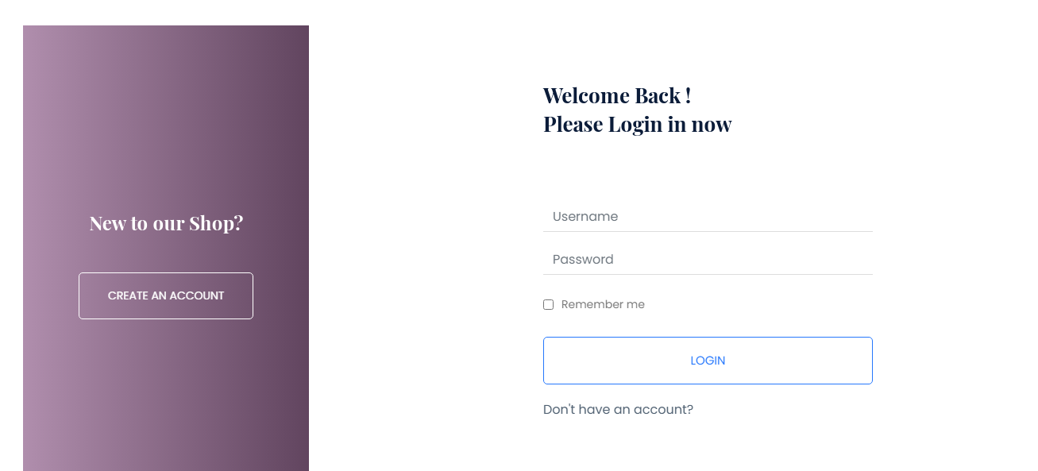

❖  **Client side Contact Us Page**

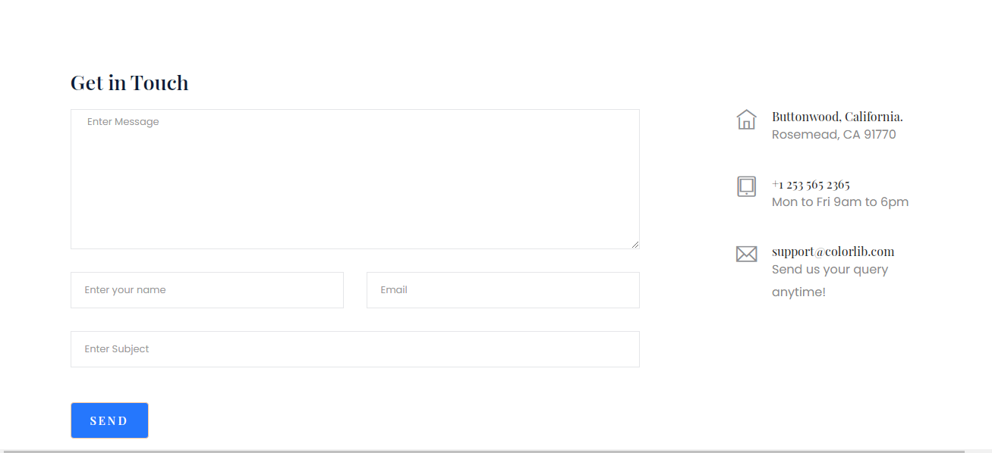

❖  **Admin side login page**

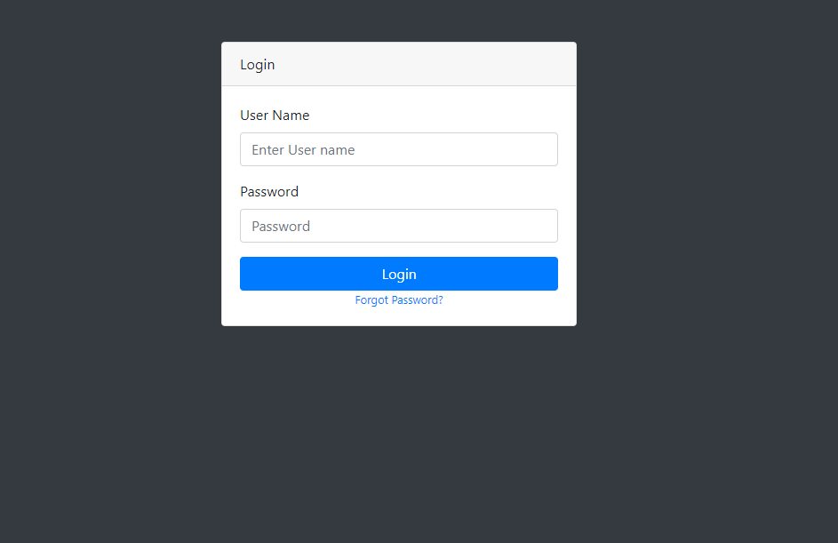

❖  **Admin side home page**

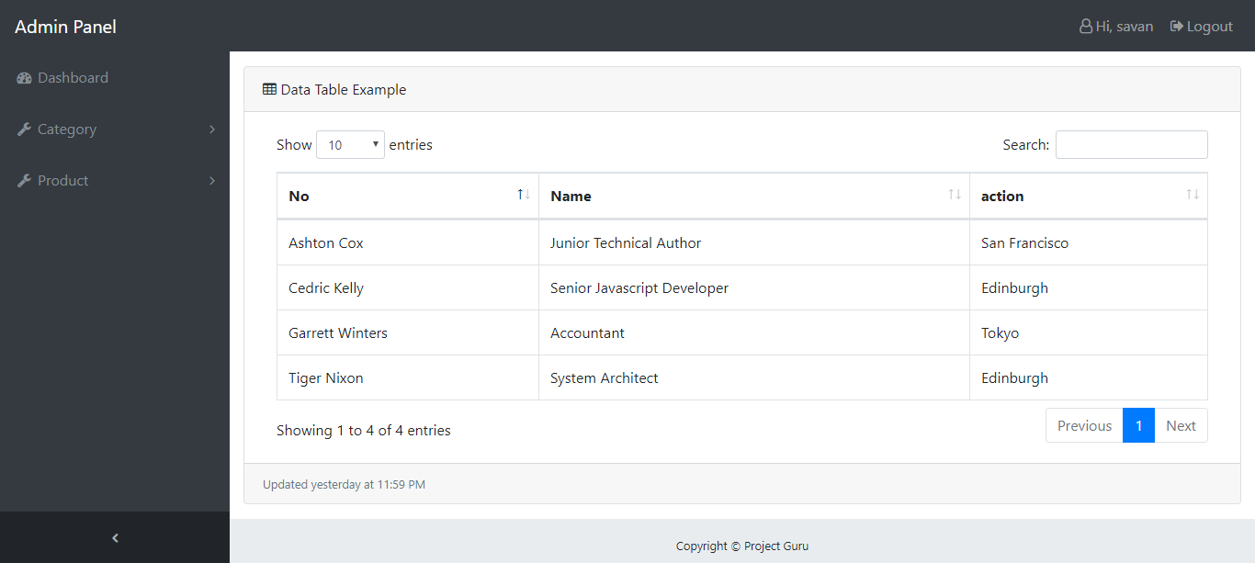

❖  **Admin side category add page**

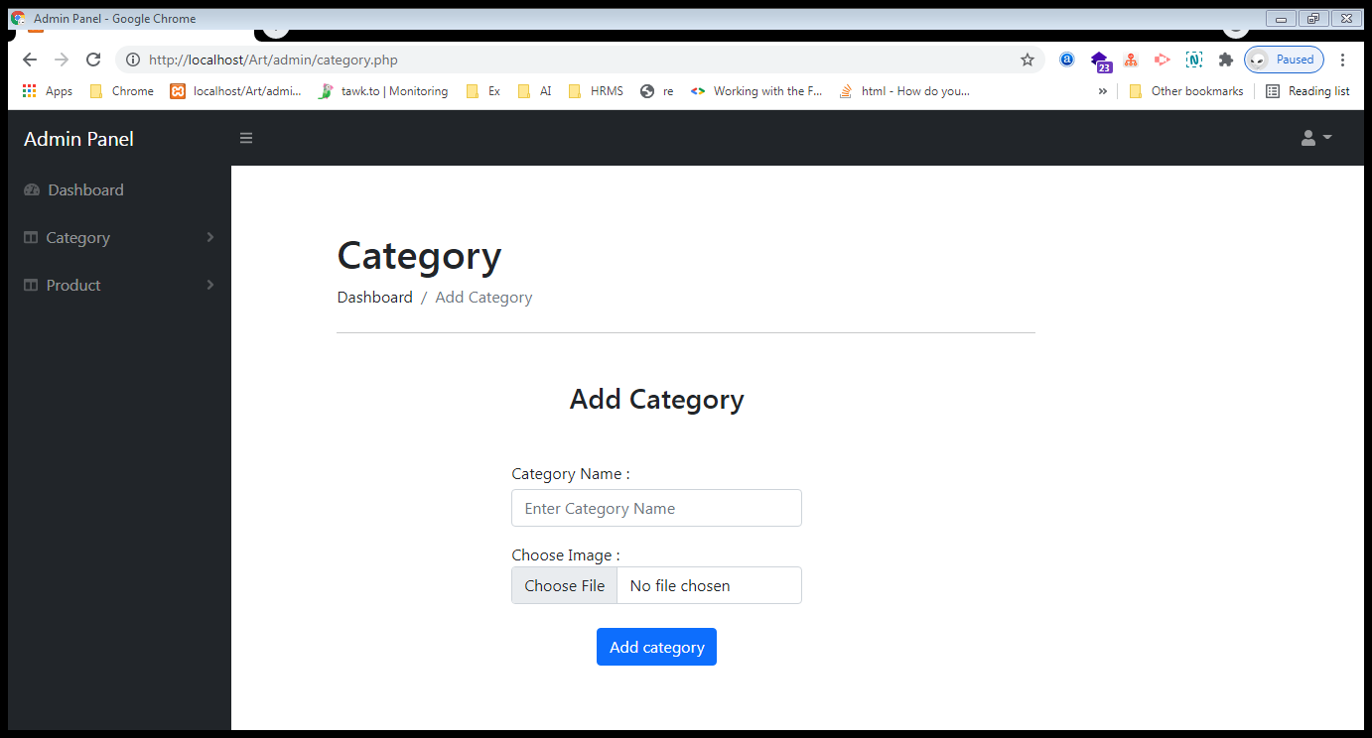

❖  **Admin side category view page**

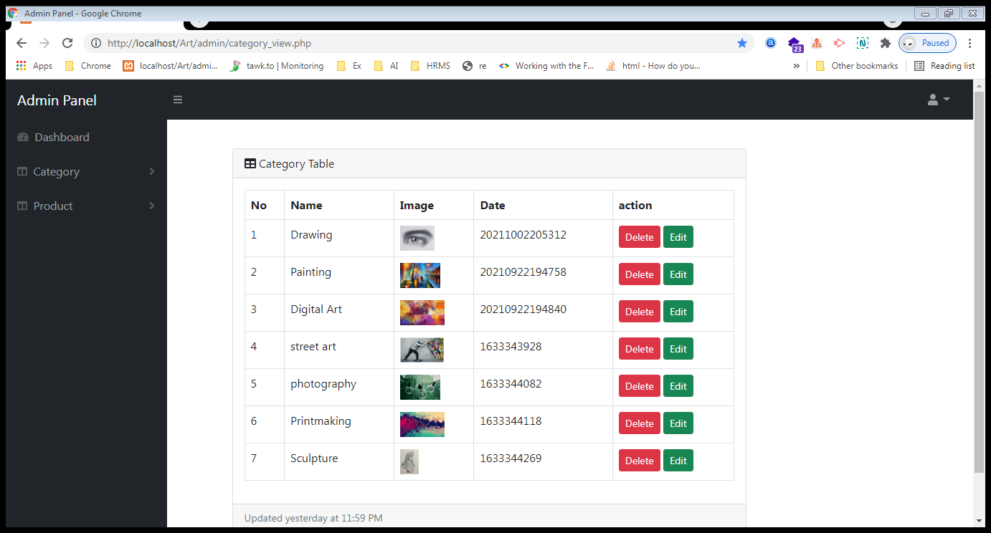

❖  **Admin side product add page**

**Page : 1**

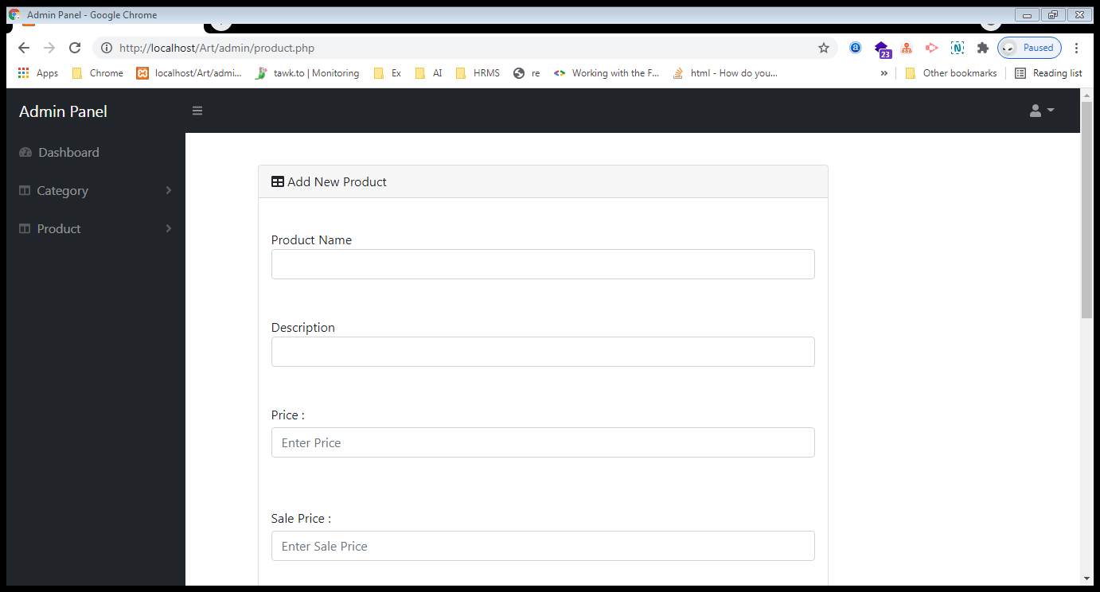

**Page : 2**

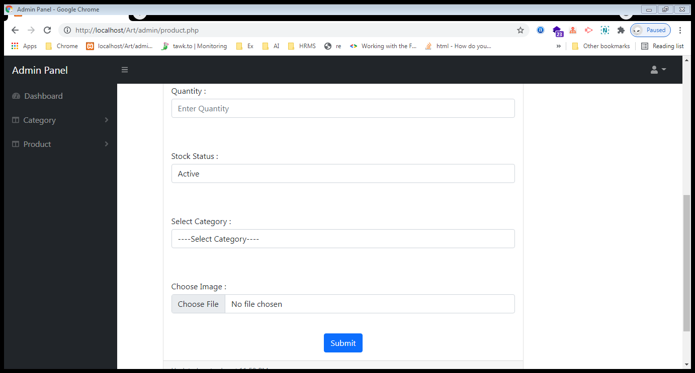

❖  **Admin side product View page**

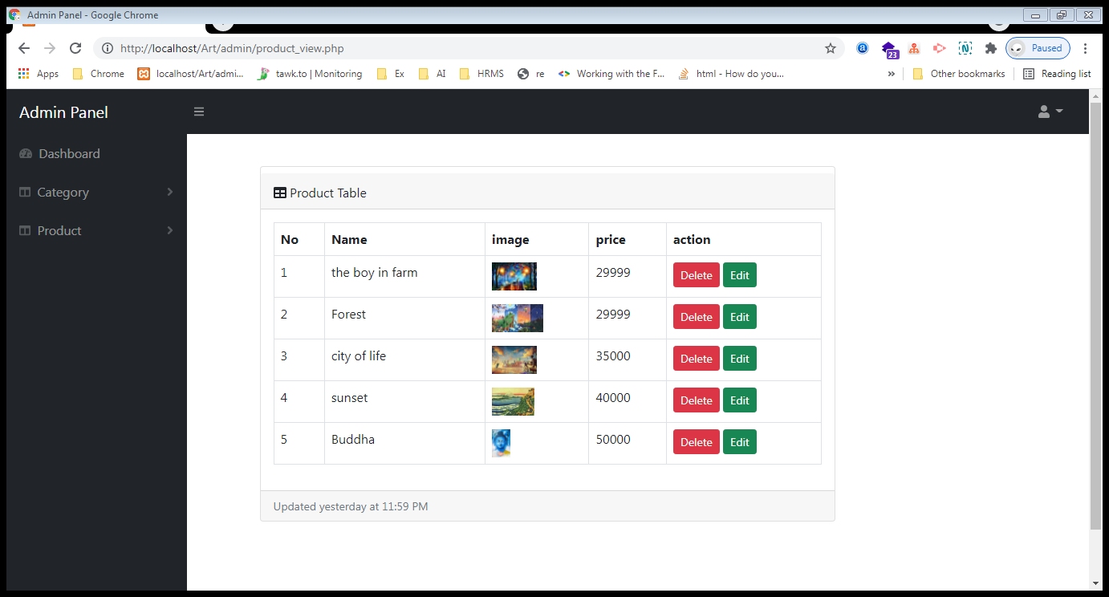

**9. Implementation Planning and Details**

❖ **Implementation Environment**

➢ This application is made by keeping in mind the basic concept of website development, the application can be used by each of the user at a time on their respective systems.

➢ At a time more than one user can view this website, they can do add to cart in any art if stock is available.

➢ This application is also made in such a way as to provide user with the most effective Graphical Interface so that the user can easily search out for different places and navigate through out the website with the ease of using this application.

➢ So, as the conclusion of above two points, this application is having the multiuser and effective GUI environment for the users.

**10. Testing**

❖ **Testing Plan:**

* A test plan is a document detailing a systematic approach to testing a system such as machine or software.
* A test plan documents the strategy that will be used to verify and ensure that a product system meets its design specification and other requirements.
* A test plan is usually prepared by or with significant input from the test engineers.

❖ **Testing Strategy:-**

How we plan to cover the product so as to develop an adequate assessment of quality.

A good test strategy is:

* Specific
* Practical
* Justified

**The purpose of a test strategy is to clarify the major tasks and challenges of the test project**.

We test the system through the following techniques.

* Data flow testing
* Functionality testing
* Unit testing
* Condition testing

**Testing Method**

There are mainly four strategies are there.

1. Static Testing

2. Dynamic Testing

3. Black Box Testing

4. White Box Testing

**1. Static Testing:**

The Verification activities fall into the category of Static Testing. During static testing, you have a checklist to check whether the work you are doing is going as per the set standards of the organization. These standards can be for Coding, Integrating and Deployment. Reviews, Inspection's and Walkthrough's are static testing methodologies.

**2. Dynamic Testing:**

Dynamic Testing involves working with the software, giving input values and checking if the output is as expected. These are the Validation activities. Unit Tests, Integration Tests, System Tests and Acceptance Tests are few of the Dynamic Testing methodologies. As we go further, let us understand the various Test Life Cycle's and get to know the Testing Terminologies. To understand more of software testing, various methodologies, tools and techniques.

**3. Black Box Testing:**

Black Box Testing is testing without knowledge of the internal workings of the item being tested. For example, when black box testing is applied to software engineering, the tester would only know the legal inputs and what the expected outputs should be, but not how the program actually arrives at those outputs. It is because of this that black box testing can be considered testing with respect to the specifications, no other knowledge of the program is necessary. For this reason, the tester and the programmer can be independent of one another, avoiding programmer bias toward his own work. For this testing, test groups are often used. Also, due to the nature of black box testing, the test planning can begin as soon as the specifications are written.

This strategy has some advantage like it is more effective on larger units of code than glass box testing; tester needs no knowledge of implementation, including specific programming.

**4. White Box Testing:-**

White box testing strategy deals with the internal logic and structure of the code. White box testing is also called as glass, structural, open box or clears box testing. The tests written based on the white box testing strategy incorporate coverage of the code written, branches, paths, statements and internal logic of the code etc. In order to implement white box testing, the tester has to deal with the code and hence is needed to possess knowledge of coding and logic i.e. internal working of the code. White box test also needs the tester to look into the code and find out which unit/statement/chunk of the code is malfunctioning.

The White Box Testing has also some advantages like as the knowledge of internal coding structure is prerequisite. It becomes very easy to find out which type of input/data can help in testing the application effectively. It helps in optimizing the code it helps in removing the extra

➢ **Testing cases:-**

|  |  |  |  |
| --- | --- | --- | --- |
| **NO.** | **Description** | **Expected Value** | **Status** |
| 1 | Testing user registration form with  password less than 8 characters | Display error message | Ok |
| 2 | Testing user name at registration if  user name is already registered | Return error with  message pls. change user name | Ok |
| 3 | Testing user name at registration if  user name is not registered | Allow | Ok |
| 4 | Testing the login form with valid  user name and password | Allow access | Ok |
| 5 | Testing the login form with invalid  username and password | Display error message Either username password is wrong. | Ok |

**11. LIMITATION AND FUTUREENHANCEMENT**

❖ **Limitation**

❖ **Future Enhancement**

❖ **Conclusion**

❖ **Bibliography/References**

➢ **BENEFIT**

•  Anyone can purchase and sell a Arts online.

• Anyone can view Art information and if anyone wants to see other arts detail

that time that user is must be login then he easily see arts detail.

• Any user can give feedback so other user has idea of our system.

➢ **LIMITATIONS**

• We have delivered our limited are arts.

• Our application not provide banking facilities. Currently we are not

providing artist can sell their arts

❖ **Future enhancement**

* In future we are providing artist panel also in this panel we are working on artist sell their products in our site

➢ Our application to provide future online banking facilities.

➢ We have delivered to every area.

➢ Better payment facilities

❖ **Conclusion**

➢ The project report entitled "ART SHOPEE" has come to its conclusion.

➢ The new system has been developed with so much care that it is free of errors and at the same time efficient and less time consuming.

➢ System is robust. Also provision is provided for future developments in the system.

❖ **References**

➢ **Reference books:**

PHP in 24 Hours, PHP Bible, for my site specially take reference from mojarato.com site.

PHP manual

JavaScript in 24 Hours

➢ **WEBSITE**

 [www.google.co](http://www.google.com/)m

 [www.wikipedia.co](http://www.wikipedia.com/)m

 [www.w3school.co](http://www.w3school.com/)m

 www.mojarto.com